Cold air curtain
SIGA 90/120/150C
Natural protection

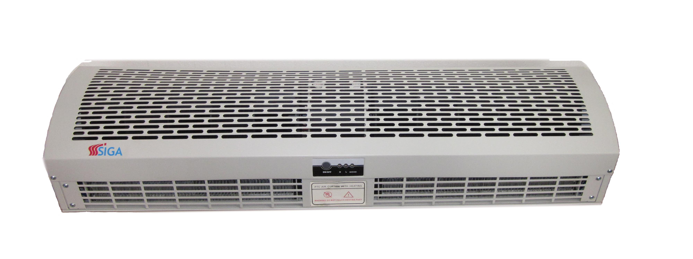

Function:
- All-metal housing, advanced fire resistance, simple installation and easy cleaning
- Optimized fan wheel with large air volume and low noise
- Applied rigid fiberglass plastic fan wheel and also quality aluminum alloy fan wheel which is specially suitable for the environment with heavy oily smoke
- Adopting optimize motor, dependable performance, motor operates 5000 hours continuously without any defects
- Flexible control methods: switch button control, remote control and automatic-door induction control
- Elegant, generous appearance design

Technical data:

 | SIGA 90C | SIGA 120C | SIGA 150C
Rated voltage (V) | 230 | 230 | 230
Rated frequency (HZ) | 50/60 | 50/60 | 50/60
Installation height (m) | 2,3 ~ 3,5 | 2,3 ~ 3,5 | 2,3 ~ 3,5
Input power (high/low) (W) | 150/120 | 220/170 | 265/210
Rated current (A) | 0,71 | 1,04 | 1,25
Air speed (m/s) | 12 | 12 | 12
Air flow rate (m³/h) | 2250 | 3000 | 3800
Noise (dB) | 57 | 59 | 62
Dimension (mm) | 900x221x183 | 1200x221x183 | 1500x221x183
Net weight (kg) | 12,7 | 15,3 | 18,6

Warranty: 2 years

